Toxic Stress
What is toxic stress?
Believe it or not, children do experience stress and many times they are unable to cope with this stress because they are so young. Because of children's limited coping skills, stress can be toxic (dangerous) for them and the effects of stress can last for weeks, months, and even years . Toxic stress can cause learning, emotional and health related issues in children and can also affect them as adults.
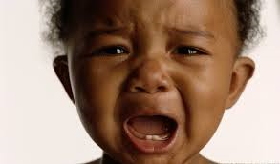

What can cause toxic stress?
- Child maltreatment (abuse or neglect)
- Exposure to physical violence or verbal arguments
- Chaotic household
- Unpredictable separations from parents

How does toxic stress affect children?
Toxic stress can affect children in the following ways:
- Limits brain development
  - Brain can grow less than normal if a child has experienced toxic stress before age 3
  - Can negatively impact the part of brain that is responsible for learning and memory
- Negatively impacts the immune system which can lead to increased risk of infections and chronic health problems
  - Increased risk for health problems such as: asthma, diabetes, & obesity
- Increases risk of anxiety, depression, anger or other emotional problems
- Increases high risk behaviors as teens or as young adults

How can I prevent toxic stress?

- Provide a secure, predictable and nurturing environment for infants and children
- Do not expose your child to stressful, traumatic events (fighting, intense arguments, violent movies)
  - Discuss conflicts outside of the presence of children
  - When speaking, use a calm voice and demeanor
- Attend parenting classes related to family engagement as well as other parenting topics
- Seek professional help for your child or yourself to properly cope with stress

