CONTINUING MEDICAL EDUCATION
100 Woodruff Circle, NE, Suite 331
Atlanta, GA 30322
Phone: 404-727-5695, Fax: 404-727-5667, Email: cme@emory.edu

Continuing Professional Development ACTIVITY PLANNING AND APPROVAL FORM
This form is designed to facilitate the planning, implementation, and evaluation of a continuing medical education activity that will comply with the ACCME Accreditation Standards of the Accreditation Council for Continuing Medical Education. After an initial meeting with OCME staff, please submit this completed form with required signatures and documentation to the CME Program Manager at least 6 - 9 months prior to the date of the program.

ACTIVITY INFORMATION
Program Title:
This activity is presented by the Department(s) of (or other entity): | Division(s) of (as applicable):
Date(s): | Anticipated Location:
Speed Type #: | ☐ Live In-Person Event – Location  ☐ Virtual Activity – (Web platform only)  ☐ Hybrid Activity – (Web platform and venue)
Anticipated Registration Fee: | Anticipated # of participants:

☐ | Course: (conference, symposium, workshop, live webcast, etc.) – Attach draft agenda with topics and times.
☐ | Enduring Material - is a non-live CME activity that "endures" over time. It is most typically a DVD, webcast, internet CME.
☐ | Regularly Scheduled Series (RSS) (EMORY ONLY)  RSS activity can be accredited for a maximum of 12 months.  A new application is required annually.  Dates:  Begin Month Year End Month Year  RSS approval is required prior to the beginning of the activity series  (Grand rounds, M&M Conferences, Tumor Boards, Journal Clubs and other education activities where the target audience is primarily Emory health professionals. |  | Occurring on:  ☐ Calendar Year (January 1 – December 31)  Frequency:  ☐ Weekly ☐ Monthly ☐ Bi-weekly  ☐ Other  ☐ Monday ☐ Tuesday ☐ Wednesday  ☐ Thursday ☐ Friday  AActivity Code if this is an existing RSS: _____  Attach session calendar with dates, speaker name, topics and times.
☐ | Other type of activity, please specify:
ACTIVITY DIRECTOR: The physician, basic scientist or administrator who will have overall responsibility for the planning, developing, implementing, and evaluating the content and logistics of this activity.
Name: |  | Title:
Email: |  | Department and Phone:
Coordinator/Assistant Name: |  | Department:
Email: |  | Phone:

CAF 2024
Page 1

Requested Credit Type:
A planner from each discipline must be on the planning committee for each selected credit type, and there must be at least one presenter (speaker) from each discipline.
Provider Type:
☐ | Physicians | ☐ | Dentists | ☐ | Physical Therapists
☐ | Nurses | ☐ | Optometrists | ☐ | Respiratory Therapists
☐ | Pharmacists | ☐ | Physician Assistants | ☐ | Social Workers
☐ | Psychologists | ☐ | Psychiatrists | ☐ | Other (specify):

ACTIVITY PLANNING COMMITTEE - List the names, affiliation and emails of persons who participate with the Activity Director on the design and implementation of this activity. PLEASE NOTE: Employees of commercial entities are prohibited from participation in planning any accredited CME activity. If the Activity Director is not a physician, at least one of the planners is required to be a physician.
Name: | Affiliation:
Email:
Name: | Affiliation:
Email:
- Check here if additional planning committee members. Attach list.
NOTE: Please see the ACCME Conflict of Interest flowchart on the last page. Use this flowchart at the beginning of your planning process for CME activities to ensure independence from ACCME-defined commercial interests. Start at “A” for step-by-step instructions for using this flowchart.

Nursing Contact Hours Nursing care is a vital component of quality patient care and nurses play an important role. Nursing contact hours may be awarded to this activity by the Emory Nursing Professional Development Center (ENPDC) if requirements are met. The most important requirement stipulates that a Nurse Planner actively participate in the planning of this activity from its inception. Would you like to apply for Nursing Contact Hours?

☐ Yes. A Nurse Planner will be assigned to you. ☐ No

Are any medical students, residents, other health professions (not physicians) engaged in the planning or delivery of this CME activity? ☐ No ☐ Yes If yes, please describe:

CAF 2024

Page 2

Commercial Relationships

Educational Grants – See reference page for additional information.
Providing CME credit for an education activity requires that the activity be:
- independent from the control of commercial entities/ineligible companies (for example, pharmaceutical companies or device manufacturers)
- content based on best scientific evidence.
- unbiased and free from product promotion.

Decisions regarding the need, educational objectives, selection and presentation of content, speakers, educational design and evaluation must be made without influence from any commercial interest/ineligible companies. Any grants and in-kind support given by a commercial supporter for this activity must be made known to the Emory CME Office. Commercial entities (ineligible companies) are prohibited from paying course directors or speakers directly.
Do you plan to solicit educational grants? ☐ No ☐ Yes
(if yes, all Letter(s) of Agreement must be signed and submitted to CME prior to the program).

If RSS – the following MOC information is not applicable
Are you applying for Maintenance of Certification (MOC) Credit approval? (Fee will apply)

If applicable, would you like to develop this educational activity to comply with requirements for MOC Credit?
☐ No ☐ Yes

Maintenance of Certification Additional Requirements:
Peer Reviewer #1 name: ; ☐ CV attached Peer Reviewer #2 name: ; ☐ CV attached (review of general and/or clinical content applicability)

APPROVAL AND RECOMMENDATION
I approve and recommend the implementation of this continuing medical education activity. I attest that this activity will comply with the Accreditation Standards of the ACCME regarding balance of scientific integrity and objectivity of content.

Department Chair (or other authority with Date
responsibility for activity budget or operations)

Activity Director Date

Executive Director, Continuing Medical Education Date
For OCME Use Only Credit Hours Approved: Date Received:
Administrative Fee: Joint provider: Contact Person: Email: Executive Director Preliminary Approval: Date:

CAF 2024

Page 3

Identifying Professional Practice Gaps
A Professional Practice Gap exists when there is a difference between the current state of skills, competence, practice, performance, or patient outcomes and the desired state.
Professional Practice Gap EXAMPLES:
- Data from a group practice indicates that HbA1c is measured in only 28% of patients that have more than 2 risk factors for Type 2 diabetes.
- National research indicates that teens living in poorer neighborhoods are receiving the HPV vaccine at rates less than the national average.
- New research methods in genomics can advance our understanding of disease mechanisms in cancer.
- Many physicians receive little formal education in operational excellence.
What Professional Practice Gaps will this education activity address? Provide two examples.

What is Needed to close the two Professional Practice Gaps you have listed above?

CAF 2024

Page 4

Sources of Educational Needs
For this education activity, how did you determine what the learner needed in order to improve their competence or performance?
Select all sources that apply and provide supportive documentation (for example, a national practice guideline, performance data, or topics from physician assessment)
Inferred | Verbalized | Observed
☐ New National Practice Standards | ☐ Past learner activity evaluation data | ☐ Patient Care Audits / Quality Improvement data
☐ Development of new technology or medications or indications | ☐ Departmental discussion meetings | ☐ Epidemiological, infection control, surgical outcomes, morbidity/mortality data
☐ Organizational, legislative or regulatory requirement that impact medical practice and/or patient care | ☐ Formal survey of potential learners | ☐ National clinical guidelines (NIH, etc.)
☐ Review of board examinations and/or Maintenance of Certification requirements | ☐ Requested by affiliated institution or physician group | ☐ Journal articles/ literature citations
☐ Other: | ☐ Other: | ☐ Other:

Desired Results (learning objectives) from the Education Activity
After attending this education activity, how will the learners’ practice change and how will their ability to perform their duties improve or their patients benefit? Please provide specific measurable learning objectives for at least one Domain.
Domain | Learning Objectives
Competence/Knowledge – Give physicians new abilities / strategies / knowledge | [EXAMPLE: The learner will be able to list recommended care for all diabetic patients.]
Performance – Help physicians modify their practices | [EXAMPLE: The learner will increase the use patient care plans that incorporate the input from dieticians, pharmacists and social workers]
Patient Outcomes / Population Health – Help improve patient outcomes | [EXAMPLE: As a result of changes in the learner’s practice, over 80% of patients received the influenza vaccine.]

CAF 2024

Page 5

Target Audience and Scope of Practice
Who are the learners you wish to target? Select all that apply.
Geographic Location: |  | Provider Type: |  | Specialty:
☐ | Internal (Emory only) | ☐ | Physicians | ☐ | All specialties | ☐ | Oncology
☐ | Local/regional | ☐ | Nurses | ☐ | Anesthesiology | ☐ | Ophthalmology
☐ | National | ☐ | Pharmacists | ☐ | Cardiology | ☐ | Orthopedics
☐ | International | ☐ | Psychologists | ☐ | Dermatology | ☐ | Otolaryngology
 |  | ☐ | Physician Assistants | ☐ | Emergency Medicine | ☐ | Pathology
 |  | ☐ | Physical Therapists | ☐ | Endocrinology | ☐ | Pediatrics
 |  | ☐ | Respiratory Therapists | ☐ | Family Medicine | ☐ | Psychiatry
 |  | ☐ | Dentists | ☐ | Internal Medicine | ☐ | Radiology
 |  | ☐ | Social Workers | ☐ | Neurology | ☐ | Surgery
 |  | ☐ | Others (specify): | ☐ | Neurosurgery | ☐ | Urology
 |  |  |  | ☐ | OB/GYN | ☐ | Other (specify):

Education Format
Based on the identified educational needs and desired results, what are the best educational formats for this education activity? Please select all that you intend to use.
Competence/ knowledge | Performance | Patient Outcomes
☐ Didactic lectures | ☐ Hands-on procedural/skills workshops | ☐ Reinforcing materials such as pocket cards, mobile instruments, etc.
☐ Small groups / Panel discussions | ☐ Interactive case-based presentations | ☐ Reinforcing activities such as chart audits, hospital QI data review, etc.
☐ Demonstrations | ☐ Simulation lab | ☐ Other:
☐ Interactive (Audience Response System | ☐ Standardized patient
☐ Other: | ☐ Other:

Outcomes Measurement
What type of evaluation method/tool(s) will you use to determine the activity’s effectiveness for achieving the desired results and creating change in the learner’s competence, performance or in-patient outcomes?
Competence/ knowledge | Performance | Patient Outcomes
☐ Post-activity survey | ☐ Peer Review / Direct Observation | ☐ Patient Chart Audits
☐ Customized Pre and Post Tests | ☐ Case Based Studies | ☐ Hospital or Practice QI data
☐ Audience Response System (ARS)  ☐ Commitment to Change Questionnaire | ☐ Follow-up survey/interview about actual change in practice (done at some interval after course) | ☐ Patient Feedback
☐ Other | ☐ Adherence to various guidelines as evidenced by QI data | ☐ Mortality/Morbidity data
CAF 2024

Page 6

National Priorities for Physician Attributes

CME activities should be developed in the context of desirable physician attributes that are related to specialty board Maintenance of Certification (MOC). Identify 1-3 competencies from the IOM/ABMS/ACGME (see below) that will be addressed in the educational activity. Place an “X” in the appropriate checkbox.

Institute of Medicine Competencies

☐ Provide patient-centered care – Identify, respect, and care about patients’ differences; coordinate continuous care; listen to, clearly inform, communicate with, and educate patients; share decision making and management; and continuously advocate disease prevention, wellness, and promotion of health lifestyles, including focus on population health.

☐ Work in interdisciplinary teams – cooperate, collaborate, communicate, and integrate care in teams to ensure that care is continuous and reliable.

☐ Employ evidence-based practice – integrate best research with clinical expertise and patient values for optimum care and participate in learning and research activities to the extent feasible.

☐ Apply quality improvement – identify errors and hazards in care; understand and implement basic safety design principles such as standardization and simplification; continually understand and measure quality care in terms of structure, process, and outcomes in relation to patient and community needs; and design and test interventions to change processes and systems of care with the objective of improving quality.

☐ Utilize informatics – communicate, manage, knowledge, mitigate error, and support decision making using information technology.
ABMS (MOC)/ACGME Competencies

☐ Patient care that is compassionate, appropriate and effective for the treatment of health problems and the promotion of health.

☐ Medical knowledge about established and evolving biomedical, clinical, and cognate (e.g., epidemiological and social-behavioral) sciences and the application of this knowledge to patient care.

☐ Interpersonal and communication skills that result in effective information exchange and teaming with patients, their families, and other health professionals.

☐ Professionalism as manifested through a commitment to carrying out professional responsibilities, adherence to ethical principles, and sensitivity to a diverse patient population.

☐ Systems-based practice, as manifested by actions that demonstrate an awareness of and responsiveness to the larger context and system for health care and the ability to effectively call on system resources to provide care that is of optimal value.

What non-educational strategies will you incorporate in the activity to enhance change in practice as a supplement to the educational activity?

The goal is to incorporate into the planning something that reinforces or extends the learning that takes place during the CME activity. i.e. providing model patient handouts; post-activity follow-up containing supplemental materials; a list of helpful URLs or smartphone apps, pocket cards with pertinent information.

CAF 2024

Page 7

Incorporating performance improvement into the curriculum

Please describe how you can incorporate opportunities for addressing patient safety, quality, implementation of best practices and overall professional practice improvement into this CME activity. i.e. (Are there any QI projects that you or your department are engaged in? Does the Risk Management department encounter some issues that your content could address? Are there billing/coding practices that can be improved related to this activity? Can you demonstrate implementation of new evidence into practice?)

Stakeholder Collaboration

Are there other Emory departments or clinical services or anyone outside of Emory (CDC, Rollins School of Public Health, GA Tech, State Department of Health) working on this issue? Will you be including them in this education activity? If yes, who and in what way?

Narrative Description of the Education Activity (This description may be used in the marketing and promotion of the activity, i.e., brochure, journal ads, websites, flyers.)
Provide a description of this program, including
- Who will benefit most by participating? (Be sure to include the target audience specialties.
- What specific content will be addressed in this activity?
- What are the most important lessons the learner will leave with?

CAF 2024
Page 8

Disclosures to Prevent Conflict of Interest

All individuals in a position to control the content of this CME activity must disclose any relationship with an ineligible company (regardless of the amount) that
- benefits the individual in any financial amount and,
- has occurred within the past 24 months.

(Ineligible companies) are those whose primary business is producing, marketing, selling, re-selling, or distributing healthcare products used by or on patients.

*If you can check any of the boxes below, you do not need to identify, mitigate, and disclose relevant financial relationships. If you are unable to check any boxes, please contact CME to implement processes for ensuring the integrity and independence of this education.

Program content will…
☐ Only address a non-clinical topic (e.g., leadership or communication skills training).

☐ Be for a learner group that is in control of the content (e.g., spontaneous case conversation among peers – not a planned event).

☐ Be a self-directed educational activity where the learner will control their educational goals and report on changes that resulted. (e.g., learning from teaching, remediation, or a personal development plan.)

A conflict of interest is present when the individual has both a financial relationship with a commercial entity and
has the opportunity to affect content relevant to the products/services of that commercial entity.

When a conflict of interest is determined to exist, the conflict must be mitigated/resolved prior to participation in this CME activity by:
  - Altering the financial relationship with the commercial entity; and/or
  - Altering the individual’s control over CME content about the products/services of the commercial entity.

Individuals who refuse to disclose their financial relationships must be excluded from participation in all aspects of the activity.

In order to preserve the independence of this continuing medical education activity, an individual with an unresolved conflict of interest must not have responsibility for, or control of, the content or planning related to the unresolved conflict. The Office of CME must receive Financial Disclosure Forms for all individuals involved in the planning (Activity Director and Planning Committee Members) and implementation (Speakers, Moderators) of the activity prior to the start of the activity. Additionally, for any disclosed potential conflict, the Worksheet for the Identification and Mitigation of Financial Relationships must be received demonstrating steps to mitigate/resolve the conflict so that the individual may participate.

CAF 2024
Page 9

Additional Comments

Full compliance with the ACCME Accreditation Standards and Policies is required for all Emory University School of Medicine continuing medical education activities. Failure to comply may result in the withdrawal of CME credit approval.
- Attachments (Please attach the following to this form):

☐ Tentative Program Agenda (including session dates and times so that credit hours can be calculated)
For RSS’s, provide sessions to be held on the designated calendar session spreadsheet.

☐ List of proposed Faculty (including name, title, affiliation, address, phone, and email address with honorarium amounts, if applicable). PLEASE NOTE: Employees of commercial entities are prohibited from participation.

☐ Financial Disclosure Form (from each person involved with the development of educational content) *
☐ Needs Assessment documentation (supporting documentation referenced in Sources of Educational Need)

☐ Preliminary budget attached? ☐ Yes ☐ N/A

NOTE - The Activity Director has the responsibility for ensuring the funding of the CME activity, making certain that there are no outstanding expenses. The Emory CME Office does not have a budget for funding CME activities but has the responsibility for tracking the CME activity budget in order to meet ACCME accreditation requirements. The CME Office can assist in the development of your budget.

Incomplete applications will be returned.
After this application and supporting documentation are reviewed and approved by the Office of Continuing Medical Education, an approval confirmation will be provided to the Activity Director and designated administrator/coordinator.

Revised: 10/09; 02/11; 7/13; 7/14; 8/15; 5/16, 10/16; 12/16; 09/21; 10/23; 1/24; 4/24

CAF 2024

Page 10

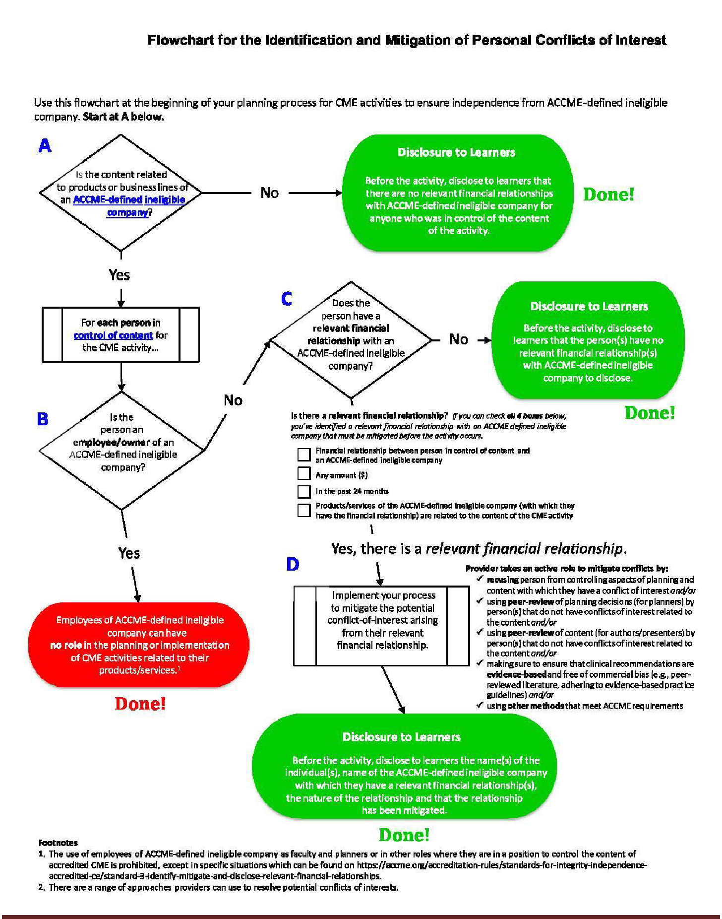
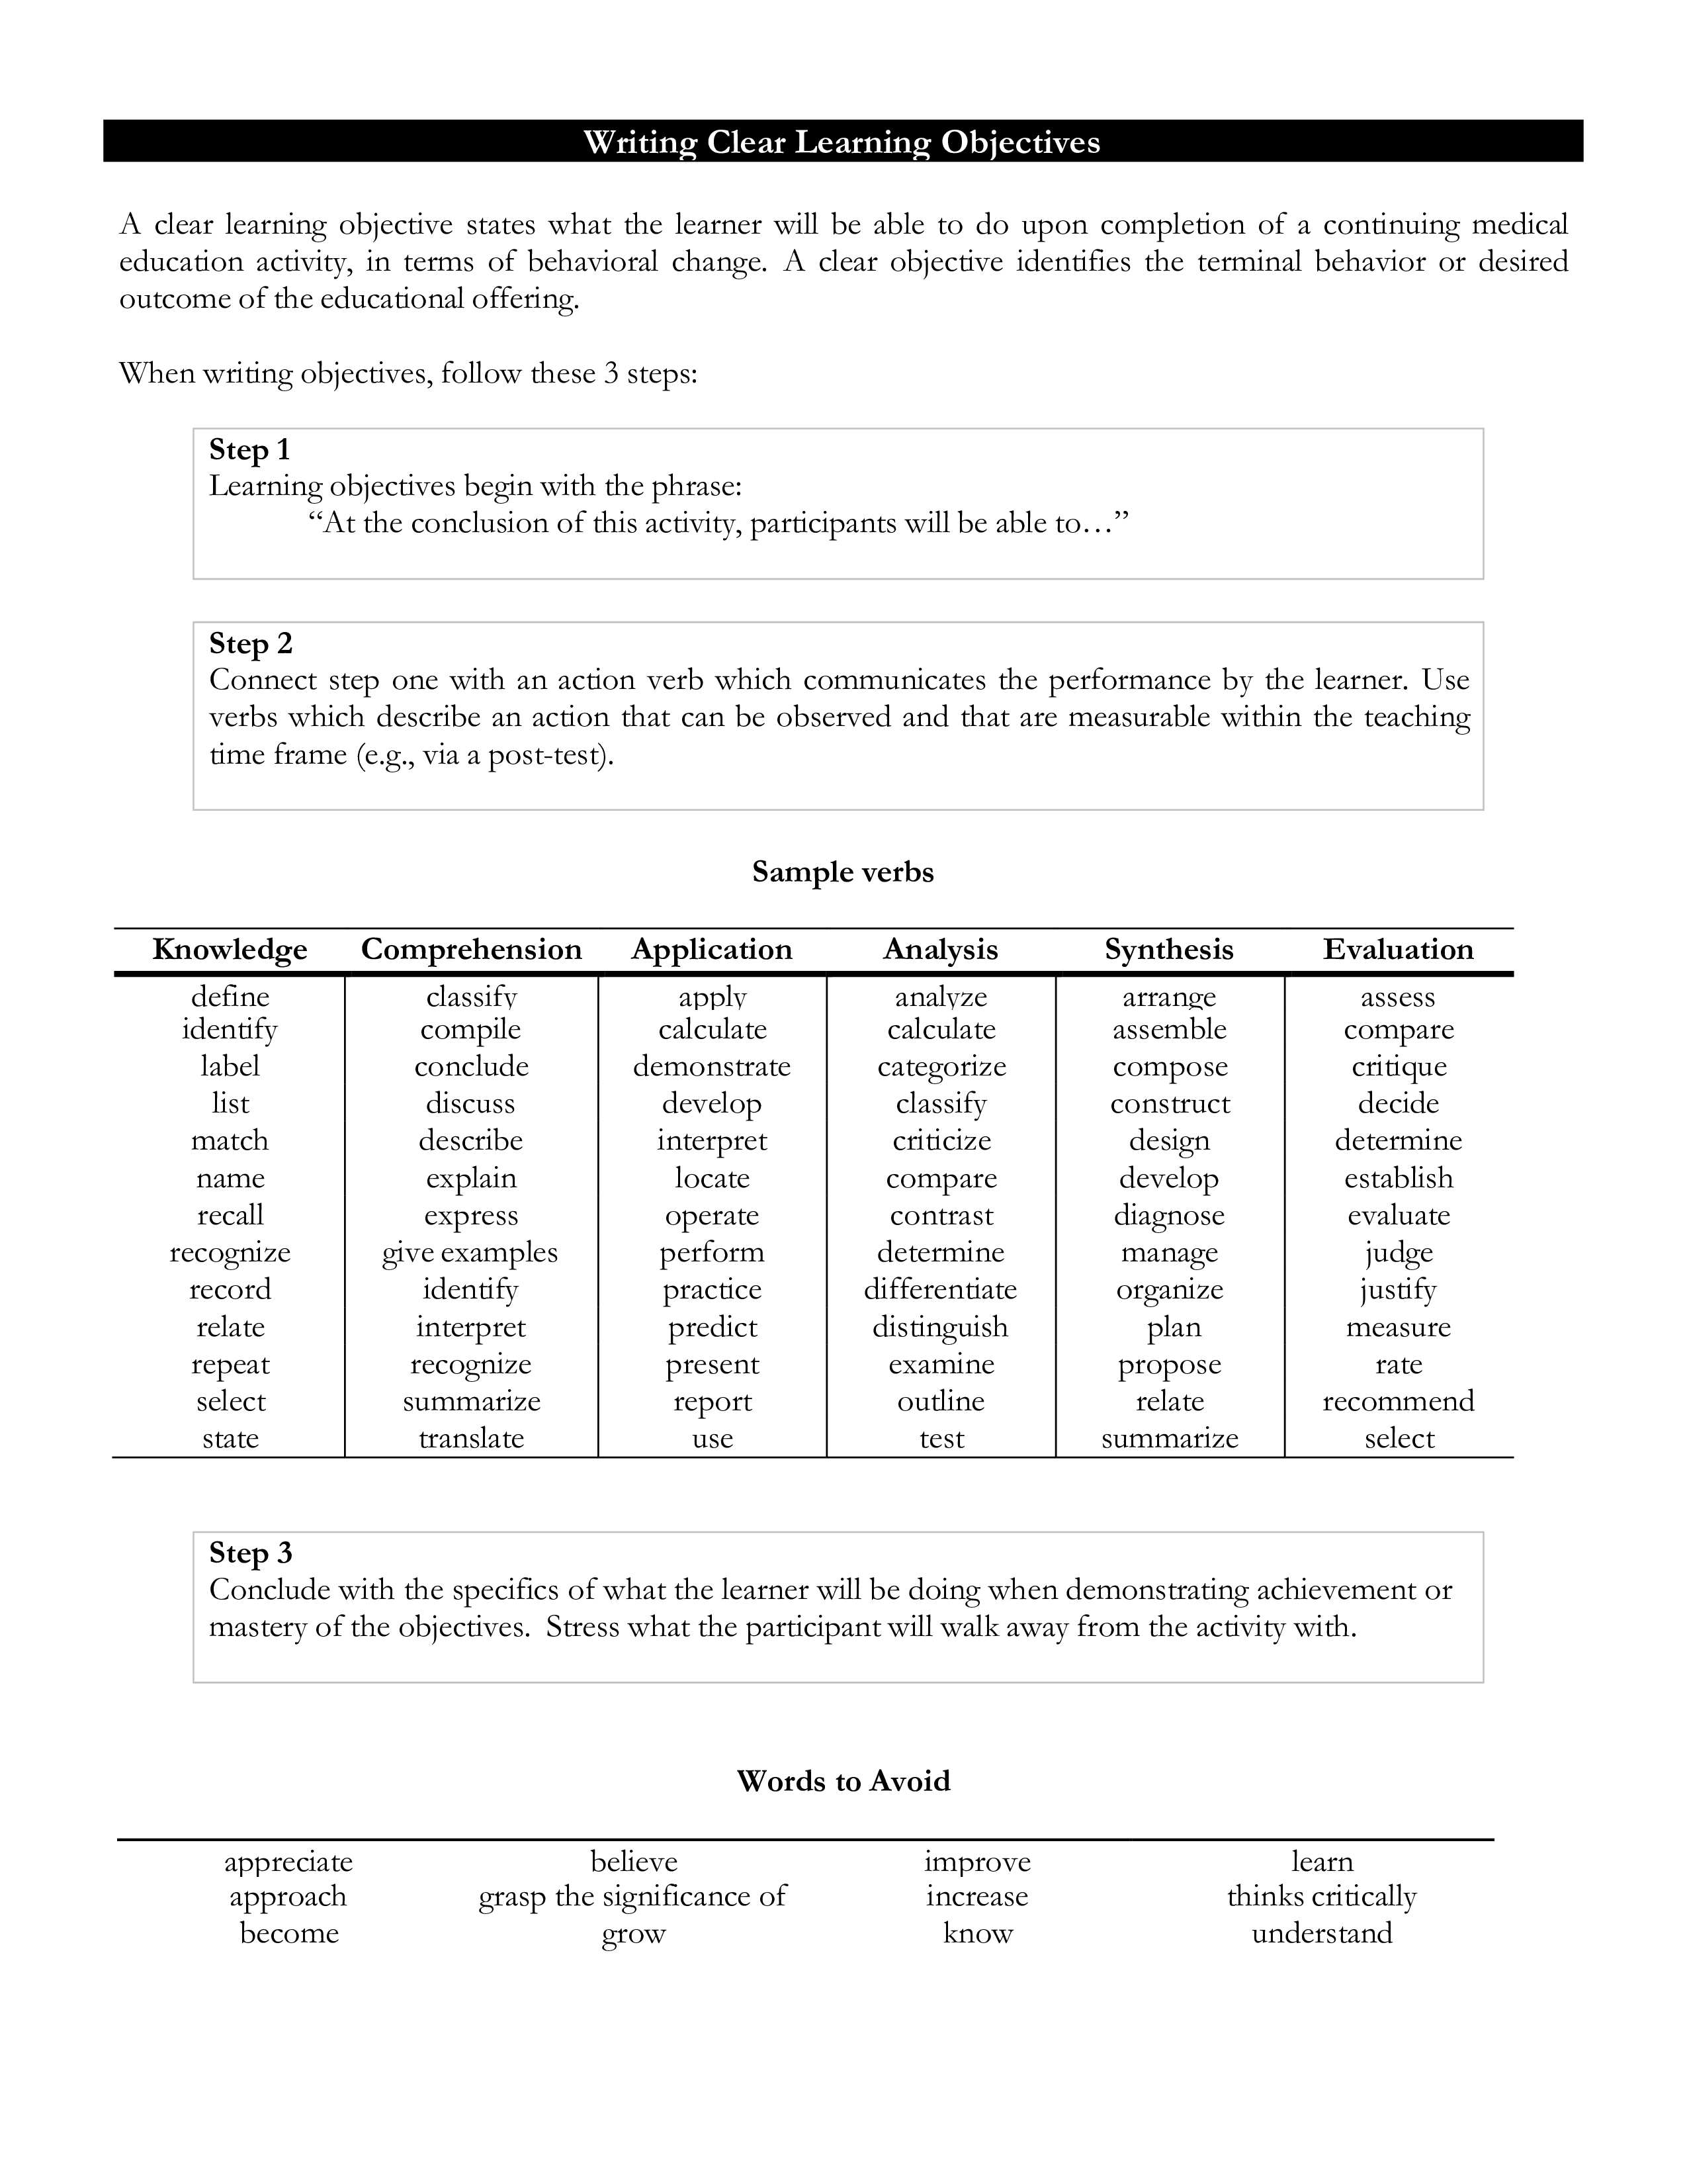
CAF 2024 Page 12

