How to setup pre-defined breakout groups in Zoom
Sources:
1. Managing Breakout Rooms
2. Pre-assigning participants to breakout rooms

- The host needs to have these two options enabled through the web client (which you can access through this link or by copying and pasting https://zoom.us/profile/setting into your browser manually). It cannot be done via the desktop client.
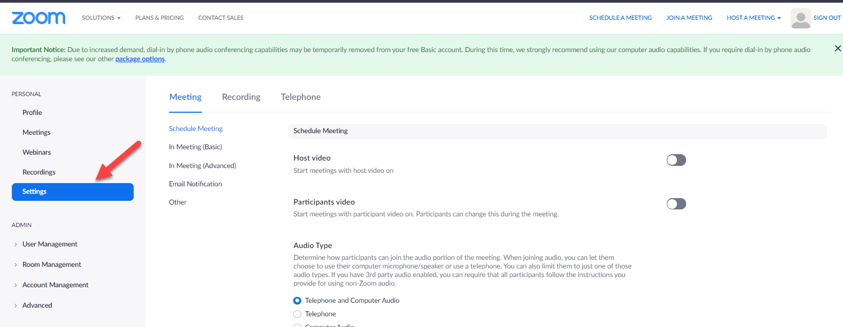
- Scroll down to the “In Meeting (Advanced)” section of the settings and make sure both options are enabled. You should see a green box appear confirming your actions.
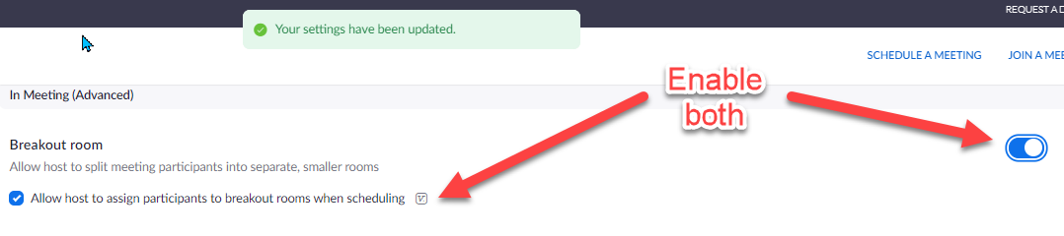
- In order to add breakout groups, you must schedule the meeting through the web browser.
- Click “Schedule a Meeting” and fill out all the necessary info.
  - note: You can also edit a previously scheduled meeting if the groups are the same)
- Make sure the 3 options below are selected.
  - You can also add alternative hosts. I haven’t tested this yet but if may be useful at some point)
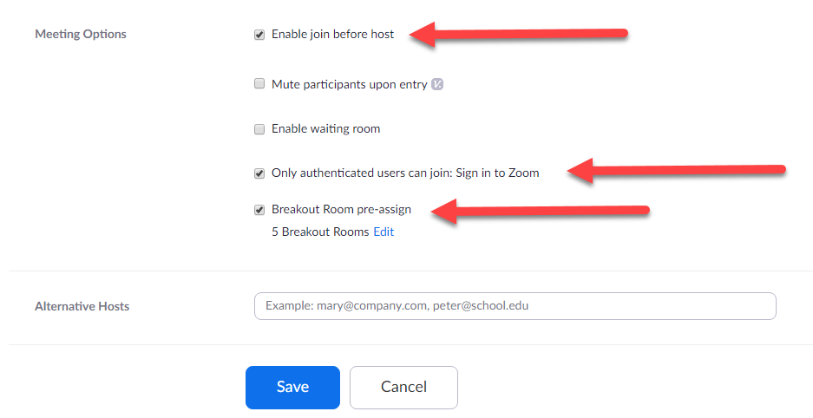

- To import the predefined breakout groups, click “Import from CSV”
  - You can either drag and drop the Excel file or click “browser” and search your computer.
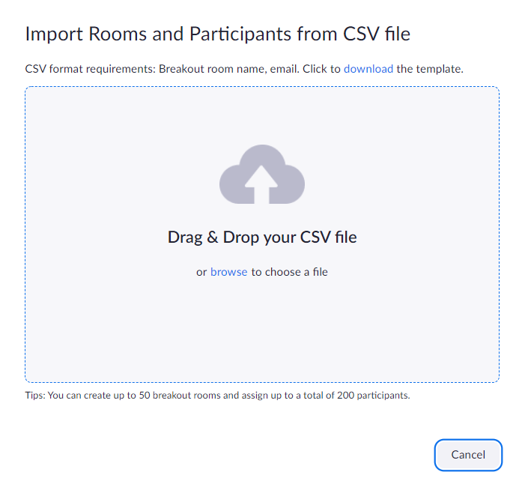

- Use the following template for the students. You can name the Rooms whatever you want. Please use the email address associated with the Zoom account that was given to the students.
  - Important: The excel document must be saved as a .csv file. It will give you a message about data loss, just click “Don’t show again.”
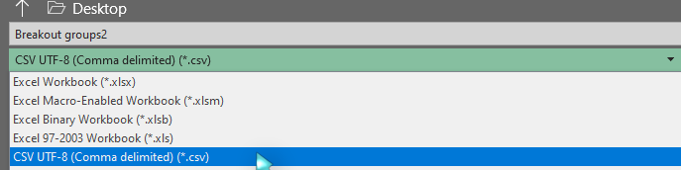
- Once you have started the meeting, you should see “Breakout groups” at the bottom. Click that.
  - If the meeting is empty, you will see “Open All Rooms” grayed out.
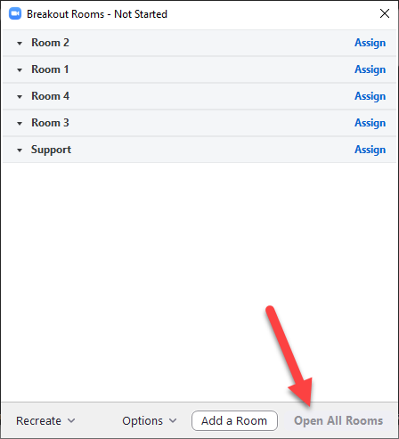
  - If there are participants that are not using the account that was in the CSV file you imported, it will look like this.
  - If the student signed in with the correct account, it should look like the following below.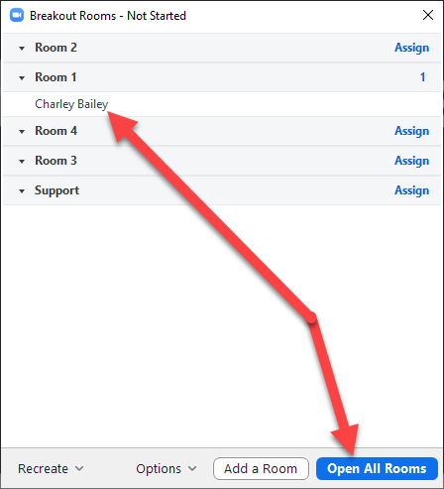

  - If, for some reason, you need to revert the breakout groups to what was originally imported, you can click “Recreate” and “Recover to pre-assigned rooms.”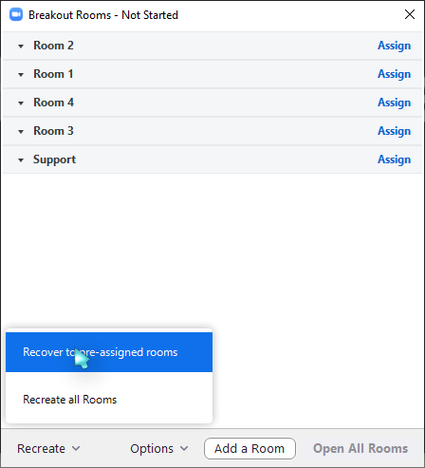

If breakout groups have started and a student has not joined their group: 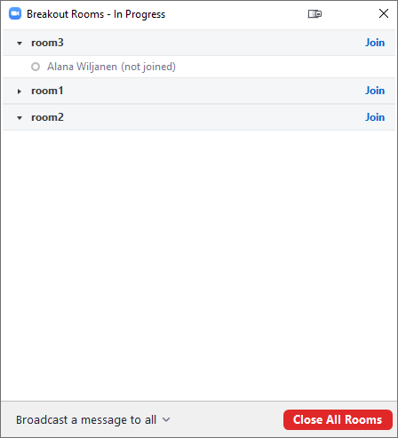

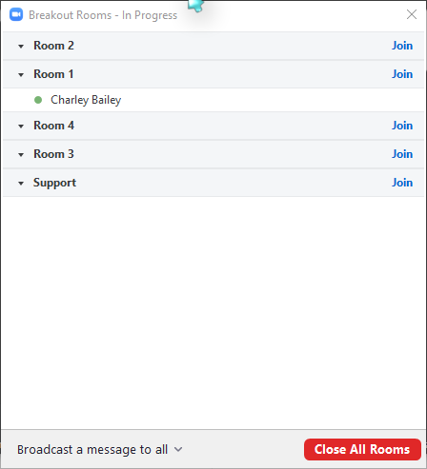
This is what it looks like when students are in their groups.

