**Instructions on how to get Updates**

When a machine is a non-domain joined, you can get your updates directly from Microsoft.

Please follow these simple instructions to download and install updates.

Please note that for third party software such as, Chrome, Firefox, Java and Adobe, most of them auto update.

**For Windows 10 (for Windows 7 see below)**:

* Click on the start menu

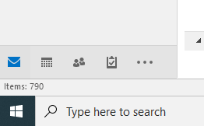

* Type “Check for updates” and click enter.  The Windows Update setting menu will open.

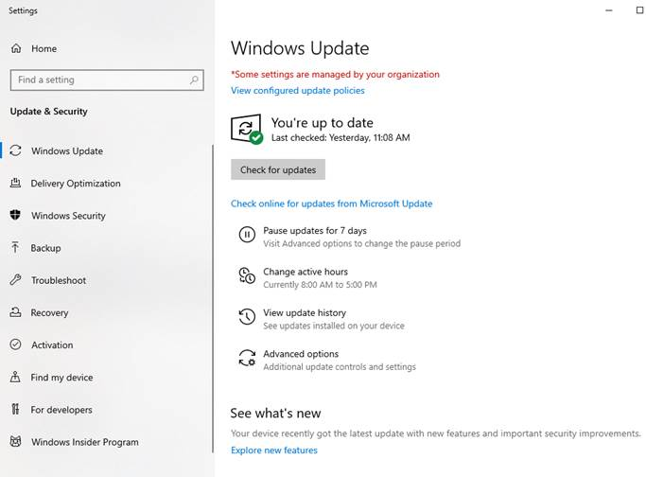

* Click on the check for updates button and windows will download all relevant software updates.  Once updates are installed, the user will be prompted to restart if necessary.

**For Windows 7**:

* Go to the start menu and click “Control Panel” on the right-hand side.

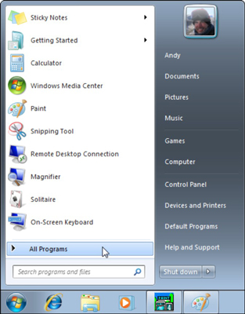

* In the control panel select windows updates toward the bottom of the screen.

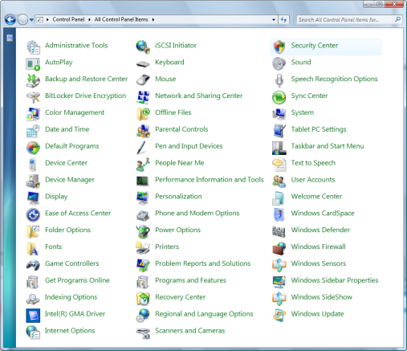

* When the windows updates menu is open select “check for updates” on the top left-hand side.  Windows will now download all necessary updates.

·         