Emory Parent Child Interaction Therapy (PCIT) Program
Marianne Celano, PhD, ABPP, Director
Emory University School of Medicine
12 Executive Park Dr., NE, Suite 200
Atlanta, GA 30329

Suggested Toys for Special Time

Below is a list of some of the toys that we love using in PCIT. They all follow the general guidelines of being open-ended, not rule-bound, not win-lose, not conducive to aggression, and great for positive caregiver-child interactions. Many of these toys will engage your 2 to 5 year old child in imaginative play, and all will give you opportunities to practice the PRIDE skills.

LEGOs®  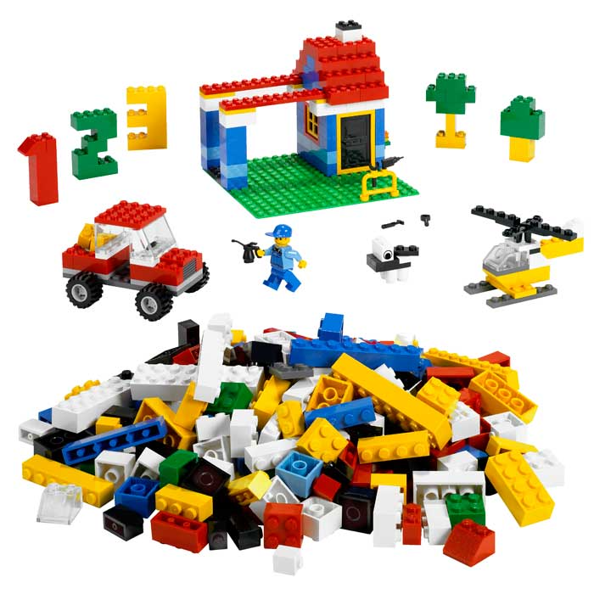 | Blocks  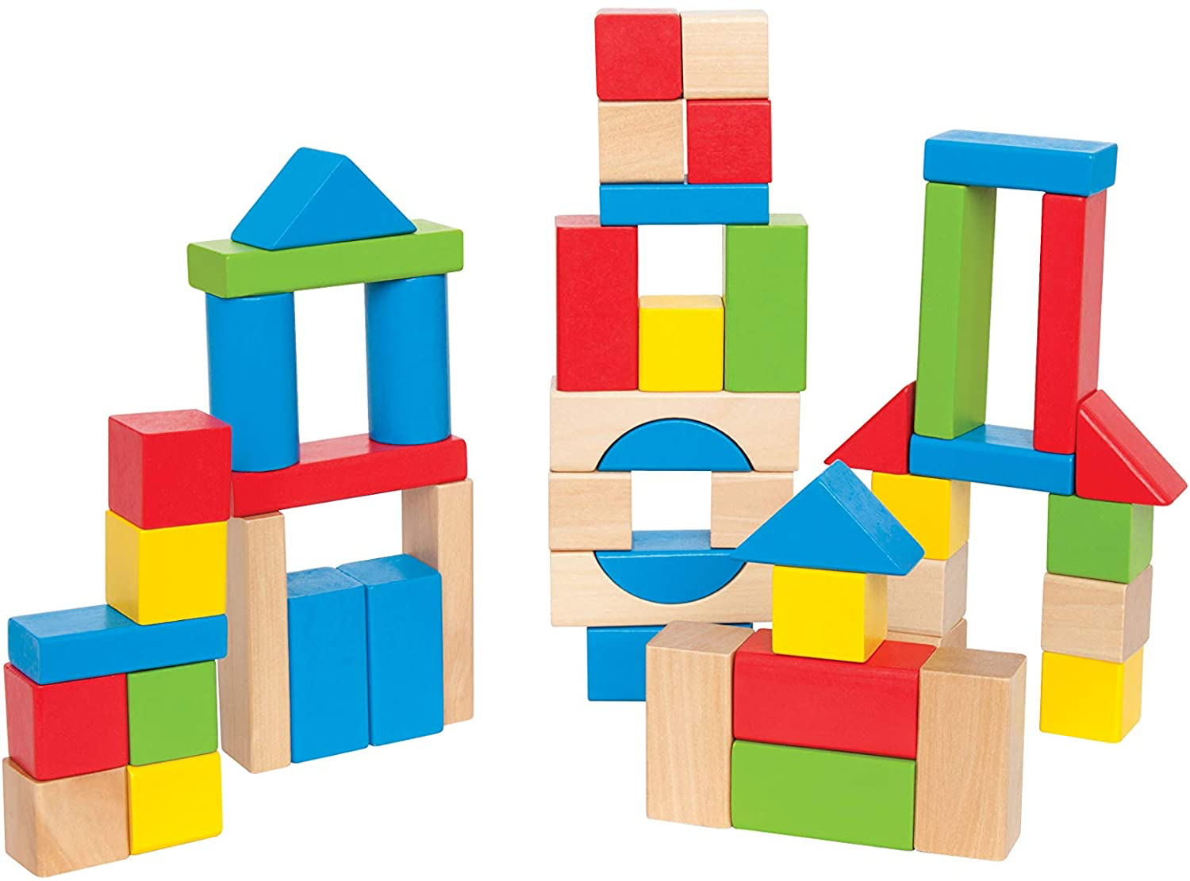 | Magna-Tiles  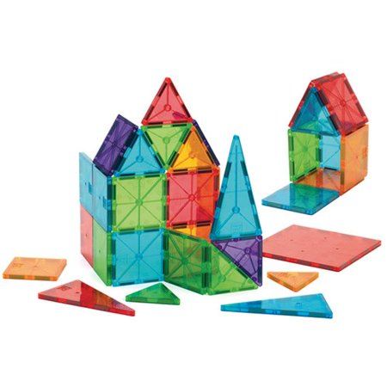
Cars or Trains  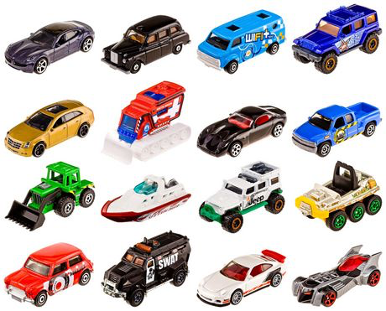 | Kitchen Toys  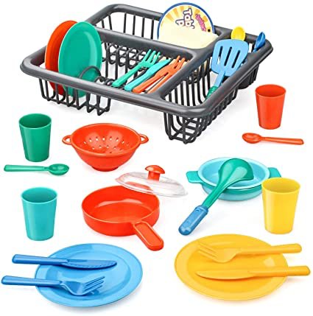 | Art Activities  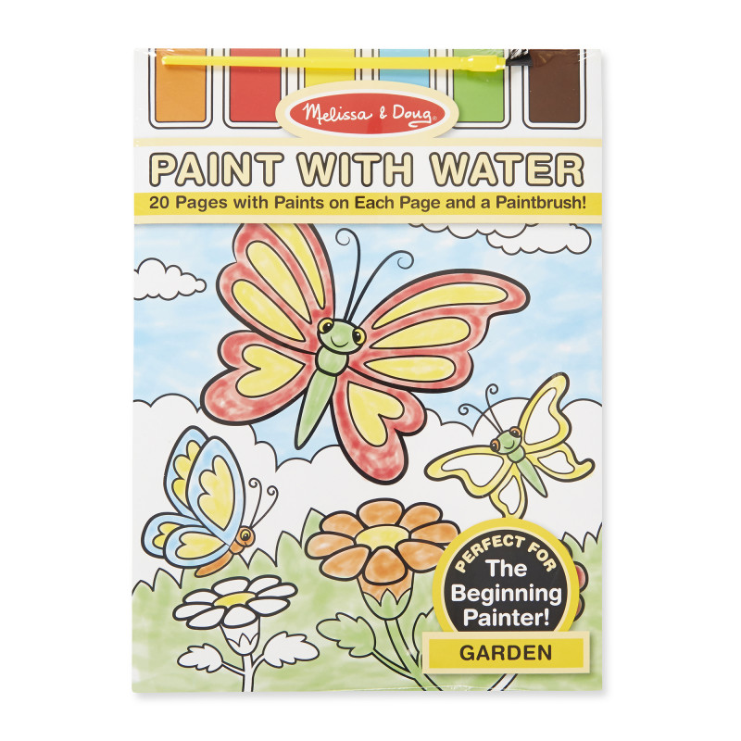
Doctor’s Kit  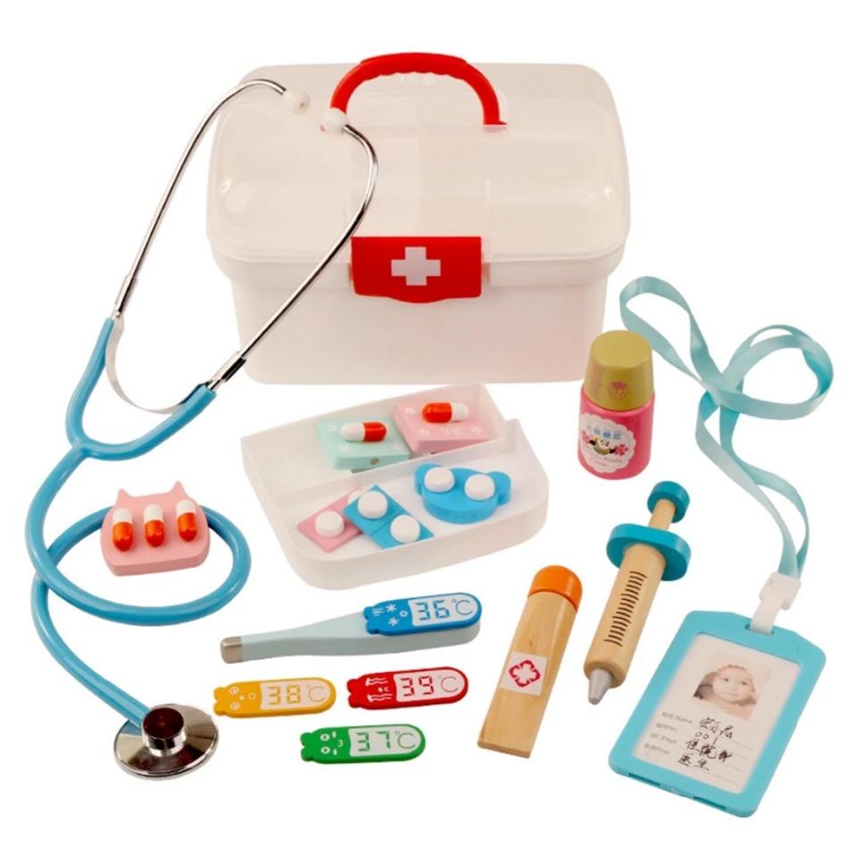 | Baby Dolls | Toy Animals

For children ages 6 and 7, the following toys and activities are likely to keep their interest, engage their creativity, and help you practice the PRIDE skills:

- Play with magnets, paper clips, metal straws
- Making necklaces, bracelets, key chains from string/wire and beads
- Making a picture frame (popsicle sticks), painting/coloring it, decorating it with shells
- Building a world with modeling clay or sand, popsicle sticks, small plastic figures
- Aim/toss activities (e.g., magnetic darts)
- Costume play, with old t-shirts or scarves, tape or safety pins, hats, shoes, masks
- Home-built forts (from chairs, blankets) or obstacle courses
- Paper crafts with scissors, glue, stickers
- Painting and decorating cardboard or wooden boxes to hold “treasures”
- Bowling
- Play-doh with cookie cutters
- Stomp Rockets®
- Nerf basketball
- Play with toys that light up or “glow in the dark”

