Emory Specialized Center of Research Excellence on Sex Differences (Emory SCORE)
Career Enhancement Core

Spring 2022
“Add an Aim” Grants
The Career Enhancement Core of the Emory Specialized Center of Research Excellence on Sex Differences (Emory SCORE) will fund up to 3 one-year, non-renewable “Add an Aim” awards in this cycle (each up to $30K plus indirect costs) for proposals that propose the addition of a new aim within a funded, currently active project that does not include a focus on women’s health, sex as a biological variable, and/or the study of sex differences.
Eligibility
Emory faculty members at any level who are eligible to receive independent (NIH R01-equivelent) funding through the University AND either:
  - have no history of NIH funding at the R01-equivalent level
(early stage investigator)
or
  - have a history of only one R01-equivalent NIH award that is not in the field of sex differences research
(early established investigator new to SABV research)
or
  - are independent NIH-funded investigators, but not in the field of sex differences research
(independent investigator new to SABV research).
Added Aim
The new aim should incorporate sex as a biological variable when examining key health influences, processes, and/or outcomes. Emory SCORE funding may be used to investigate sex-based differences alone, or sex and gender-based differences in conjunction with each other, but it may not be used to investigate gender-based differences alone. (See NIH definitions of ‘sex’ and ‘gender’ terms on next page).
Applicants are encouraged to consult CEC Co-Director Dr. Kimbi Hagen (see contact information below) before submitting an LOI to determine if a proposed applicant is eligible and the proposed project is in line with the funding mechanism’s purpose and goals.

Key Dates:
 | Date | Notes
Letter of intent form due | April 15, 2022 | See: https://form.jotform.com/EmorySCORE/LOI
Application due | May 1, 2022 | Submit to: https://form.jotform.com/EmorySCORE/Application
Notification of review results | June 1, 2022 | A brief written summary statement will be provided
Project Period begins | June 15, 2022* | Regulatory approvals must be in place before funding is released
Project Period ends | May 31, 2023 | This date coincides with end of the SCORE’s current project period

* The timing of the release of a funded project’s SpeedType will be dependent on when the SCORE’s Year 05 NIH NOA arrives (typically in August) and how long it takes Emory to set up the new projects. SCORE awards that do not have other funds to draw on in the interim will be unable to begin funded activities on June 15, 2022.
NIH definition of sex vs gender:
"‘Sex’ refers to biological differences between females and males, including chromosomes, sex organs, and endogenous hormonal profiles. ‘Gender’ refers to socially constructed and enacted roles and behaviors which occur in a historical and cultural context and vary across societies and over time. All individuals act in many ways that fulfill the gender expectations of their society. With continuous interaction between sex and gender, health is determined by both biology and the expression of gender.” (https://orwh.od.nih.gov/sex-gender)

The 4 Cs of Studying Sex to Strengthen Science
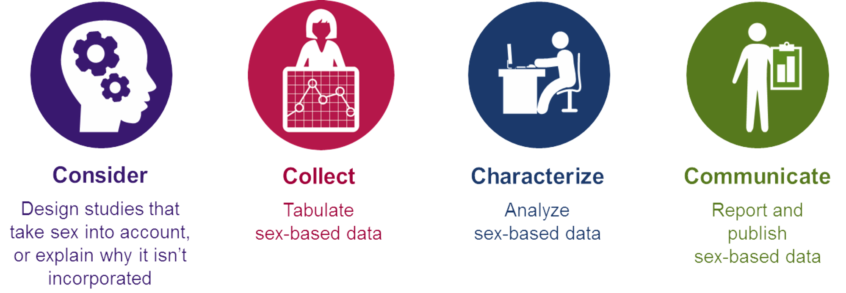
Rationale
The Emory (U54AG062334) SCORE is funded by the NIH to promote the NIH Policy on Sex as a Biological Variable (https://orwh.od.nih.gov/sex-gender/nih-policy-sex-biological-variable). That policy states:
“[Historically]… biomedical research has focused on male animals and cells. An over-reliance on male animals and cells may obscure understanding of key sex influences on health processes and outcomes.
“Accounting for sex as a biological variable begins with the development of research questions and study design. It also includes data collection and analysis of results, as well as reporting of findings. Consideration of sex may be critical to the interpretation, validation, and generalizability of research findings. Adequate consideration of both sexes in experiments and disaggregation of data by sex allows for sex-based comparisons and may inform clinical interventions. Appropriate analysis and transparent reporting of data by sex may therefore enhance the rigor and applicability of preclinical biomedical research.
“NIH expects that sex as a biological variable will be factored into research designs, analyses, and reporting in vertebrate animal and human studies. Strong justification from the scientific literature, preliminary data, or other relevant considerations must be provided for applications proposing to study only one sex.”

Application Instructions:
- Read NIH NOT-OD-15-102: https://grants.nih.gov/grants/guide/notice-files/not-od-15-102.html
(Consideration of Sex as a Biological Variable in NIH-funded Research)
- Watch the videos at https://orwh.od.nih.gov/research/sex-gender/methods-and-techniques
(Methods and Techniques for Integrating Sex into Research)
- Fill out and submit an LOI form at https://form.jotform.com/EmorySCORE/LOI
- Prepare an application packet that includes:
  - Single pdf containing a copy of the base grant’s:
    - SA page and research strategy
    - Budget Justification
  - Base grant NOA
  - SCORE Application Packet:
    - Added Aim page (1 page)
Provide enough information about the base grant’s aims to make it clear how this added aim fits into the larger project
    - Research Strategy (1-2 pages)
Use the following section headers:
Significance
Include justification for the research, as related to sex differences
Approach
Feasibility
Include proposed time line
How this Proposal Augments my Currently Funded Award
    - Future Plans for NIH Applications (1 page)
Describe how findings from the proposed research will help ground a future NIH application that will advance knowledge about sex differences, either in general or in a specific field of research. Include an outline of the remaining experiments or data collection, if any, that will need to take place before a follow-on NIH application based on findings of the current research may be submitted.
The content of this page will carry considerable weight on review.
    - Biosketches: Applicant and other key personnel
    - Budget: R&R, NOT modular
      - Indirect Costs should be included and budgeted at 8%.
      - It is strongly recommended that you include budgeted effort for statistical support if this is not already provided for in the base grant project.
      - Funds may be requested for travel and activities associated with writing an NIH research grant proposal based on project findings and/or attending meetings to establish collaborations or to present project-related data. Supported travel must be completed within the award’s project period.
      - Do not request:
        - Salary or travel for senior faculty
        - Equipment purchases of > $5,000
    - Budget Justification
- Submit the Application:
  - Upload three application documents to: https://form.jotform.com/EmorySCORE/Application
    - Base Grant information, saved as a single pdf
    - Base Grant NOA
    - SCORE application packet documents, saved as a single pdf
      - Specific Aims
      - Research Strategy
      - Future Plans for NIH Applications
      - Biosketches
      - Budget
      - Budget Justification

RELEASE OF FUNDS
A response to the summary statement and proof of all necessary institutional approvals (e.g. IRB/HIC, IACUC) must be provided to the SCORE prior to release of funds. Additional stipulations may also be included in the Notice of Award.

RESPONSIBILITIES OF SCORE AWARDEES:
- Complete funded activities on or prior to 05/31/23 (i.e. end of the SCORE’s current NIH-funded project period).
- Participate in developmental and training activities sponsored by the Career Enhancement Core (e.g., sex and gender training, research in progress seminars) as required by our funding agency, the NIH Office of Research in Women’s Health (NIH/ORWH).
- Present research projects at research seminars, national meetings.
- Serve as peer reviewers for future Emory SCORE applications.
- Participate in regular progress meetings with the SCORE CEC director and submit progress reports as required in the NOA.
- Submit a poster at the annual Emory SCORE “How to Incorporate SABV in Your Research” Workshop
- Acknowledge SCORE funding in all presentations and publications.

CONTACTS:

Scientific Questions: Application or Administrative Quetions
Dr. Kimbi Hagen Dr. Shannon Walker
Career Enhancement Core Co-Director Emory SCORE Program Director
404-310-0929 404-251-8937
kbs.hagen@emory.edu shannon.walker@emory.edu

