Explanation of SCORE Peer Review Criteria

Only the review criteria described below will be considered in the review process. These criteria are adapted from the NIH criteria updated for applications after January 25, 2019.

For this SCORE announcement note the following:
The grant supports discrete, well-defined projects that account for sex as a biological variable when examining key sex influences on health processes and outcomes. The project should be realistically completed in one year and require limited levels of funding. Because the research project usually is limited, the grant application may not contain extensive detail or discussion. Accordingly, reviewers should evaluate the conceptual framework and general approach to the problem. Appropriate justification for the proposed work can be provided through literature citations, data from other sources, or from investigator-generated data. Preliminary data are not required, particularly in applications proposing pilot or feasibility studies.

Overall Impact
Reviewers will provide an overall impact score to reflect their assessment of the likelihood for the project to lead to a fundable NIH application, as well as to exert a sustained, powerful influence on the research field(s) and on the field of gender and sex research. Reviewers should consider the following review criteria and additional review criteria (as applicable for the project proposed).

Scored Review Criteria
Reviewers will consider each of the review criteria below in the determination of scientific merit, and give a separate score for each. An application does not need to be strong in all categories to be judged likely to have major scientific impact. For example, a project that by its nature is not innovative may be essential to advance a field.

Significance
Does the project address an important problem or a critical barrier to progress in the field? Is the focus on sex/gender differences appropriate/justified? Is the prior research that serves as the key support for the proposed project rigorous? If the aims of the project are achieved, how will scientific knowledge, technical capability, and/or clinical practice be improved? How will successful completion of the aims change the concepts, methods, technologies, treatments, services, or preventative interventions that drive this field?

Investigator(s) (Including mentors, co-mentors, and consultants/collaborators)
Are the PD(s)/PI(s), collaborators, and other researchers well suited to the project? If Early Stage Investigators or those in the early stages of independent careers, do they have appropriate experience and training? Is the mentoring plan (provided in the letter from the mentor) clear and appropriate for the investigator’s level of training. If the project is collaborative or multi-PD/PI, do the investigators have complementary and integrated expertise; are their leadership approach, governance and organizational structure appropriate for the project?

Innovation
Does the application challenge and seek to shift current research or clinical practice paradigms of sex/ gender research by utilizing novel theoretical concepts, approaches or methodologies, instrumentation, or interventions? Are the concepts, approaches or methodologies, instrumentation, or interventions novel to one field of research or novel in a broad sense? Is a refinement, improvement, or new application of theoretical concepts, approaches or methodologies, instrumentation, or interventions proposed?

Approach (including time line)
Are the overall strategy, methodology, and analyses well-reasoned and appropriate to accomplish the specific aims of the project? Have the investigators included plans to address weaknesses in the rigor of prior research that serves as the key support for the proposed project? Have the investigators presented strategies to ensure a robust and unbiased approach, as appropriate for the work proposed? Are potential problems, alternative strategies, and benchmarks for success presented? If the project is in the early stages of development, will the strategy establish feasibility and will particularly risky aspects be managed? Have the investigators presented adequate plans to address sex as a biological variable, such for studies in vertebrate animals or human subjects? Is the timeline feasible for a one-year project?

If the project involves human subjects and/or NIH-defined clinical research, are the plans to address
1) the protection of human subjects from research risks, and
2) inclusion (or exclusion) of individuals on the basis of sex/gender, race, and ethnicity, as well as the inclusion or exclusion of individuals of all ages (including children and older adults), justified in terms of the scientific goals and research strategy proposed?

Environment (Including institutional commitment to the candidate)
Will the scientific environment in which the work will be done contribute to the probability of success? Are the institutional support, equipment and other physical resources available to the investigators adequate for the project proposed? Will the project benefit from unique features of the scientific environment, subject populations, or collaborative arrangements?

Potential to contribute to a fundable NHI application
If the aims of the project are achieved, will the outcomes lead to data/findings that will provide justification and support for a larger project submitted to NIH?

Additional Review Criteria
As applicable for the project proposed, reviewers will evaluate the following additional items while determining scientific and technical merit, and in providing an overall impact score, but will not give separate scores for these items.

Protections for Human Subjects
For research that involves human subjects but does not involve one of the categories of research that are exempt under 45 CFR Part 46, the reviewer will evaluate the justification for involvement of human subjects and the proposed protections from research risk relating to their participation according to the following five review criteria: 1) risk to subjects, 2) adequacy of protection against risks, 3) potential benefits to the subjects and others, 4) importance of the knowledge to be gained, and 5) data and safety monitoring for clinical trials.

For research that involves human subjects and meets the criteria for one or more of the categories of research that are exempt under 45 CFR Part 46, the committee will evaluate: 1) the justification for the exemption, 2) human subjects involvement and characteristics, and 3) sources of materials. For additional information on review of the Human Subjects section, please refer to the Guidelines for the Review of Human Subjects.
Inclusion of Women, Minorities, and Individuals Across the Lifespan
When the proposed project involves human subjects and/or NIH-defined clinical research, the committee will evaluate the proposed plans for the inclusion (or exclusion) of individuals on the basis of sex/gender, race, and ethnicity, as well as the inclusion (or exclusion) of individuals of all ages (including children and older adults) to determine if it is justified in terms of the scientific goals and research strategy proposed. For additional information on review of the Inclusion section, please refer to the Guidelines for the Review of Inclusion in Clinical Research.

Vertebrate Animals
The committee will evaluate the involvement of live vertebrate animals as part of the scientific assessment according to the following criteria: (1) description of proposed procedures involving animals, including species, strains, ages, sex, and total number to be used; (2) justifications for the use of animals versus alternative models and for the appropriateness of the species proposed; (3) interventions to minimize discomfort, distress, pain and injury; and (4) justification for euthanasia method if NOT consistent with the AVMA Guidelines for the Euthanasia of Animals. Reviewers will assess the use of chimpanzees as they would any other application proposing the use of vertebrate animals. For additional information on review of the Vertebrate Animals section, please refer to the Worksheet for Review of the Vertebrate Animal Section.

Biohazards
Reviewers will assess whether materials or procedures proposed are potentially hazardous to research personnel and/or the environment, and if needed, determine whether adequate protection is proposed.

Resubmissions (not applicable for SCORE 2019)
For Resubmissions, the committee will evaluate the application as now presented, taking into consideration the responses to comments from the previous scientific review group and changes made to the project.

Revisions (not applicable for SCORE 2019)
For Revisions, the committee will consider the appropriateness of the proposed expansion of the scope of the project. If the Revision application relates to a specific line of investigation presented in the original application that was not recommended for approval by the committee, then the committee will consider whether the responses to comments from the previous scientific review group are adequate and whether substantial changes are clearly evident.

Additional Review Considerations
As applicable for the project proposed, reviewers will consider each of the following items, but will not give scores for these items, and should not consider them in providing an overall impact score.

Select Agent Research
Reviewers will assess the information provided in this section of the application, including 1) the Select Agent(s) to be used in the proposed research, 2) the registration status of all entities where Select Agent(s) will be used, 3) the procedures that will be used to monitor possession use and transfer of Select Agent(s), and 4) plans for appropriate biosafety, biocontainment, and security of the Select Agent(s).

Authentication of Key Biological and/or Chemical Resources:
For projects involving key biological and/or chemical resources, reviewers will comment on the brief plans proposed for identifying and ensuring the validity of those resources.

Budget and Period of Support
Reviewers will consider whether the budget and the requested period of support are fully justified and reasonable in relation to the proposed research.

Reviewer Guidance on Scoring
The table below provides a guide for reviewers in assigning overall impact scores and individual criterion scores. Overall impact, for a research project, is the project’s likelihood to have a sustained, powerful influence on the research field(s) involved, but may be defined differently for different types of applications. Each review criterion should be assessed based on the strength of that criterion in the context of the work being proposed. As a result, a reviewer may give only moderate scores to some of the review criteria but still give a high overall impact score because the one review criterion critically important to the research is rated highly; or a reviewer could give mostly high criterion ratings but rate the overall impact score lower because the one criterion critically important to the research being proposed is not highly rated.
- An application does not need to be strong in all categories to be judged likely to have major impact, e.g., a project that by its nature is not innovative may be essential to advance a field.
- A score of 5 is a good, medium-impact application.
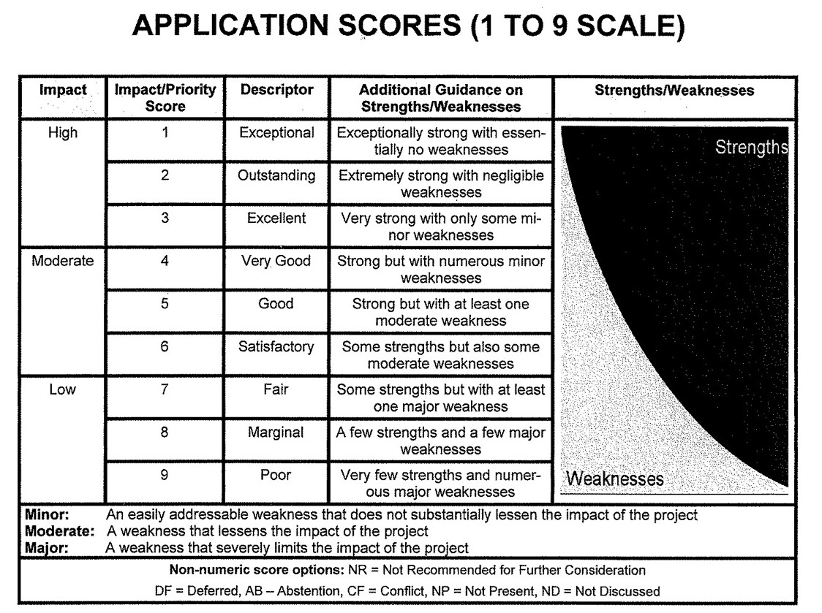
- The entire scale (1-9) should always be considered.

